Data Sheet

Product: iSub
Audio System

Smart Harmony iSub is a stand-alone powered subwoofer. By connecting the iSub with two compact loudspeakers (not included), it will provide full strength Hi-Fi quality performance. iSub is the powerful active subwoofer with attractive styling outlook. It can be easily installed with any 2.1 home entertainment systems.

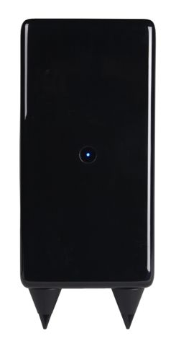 | 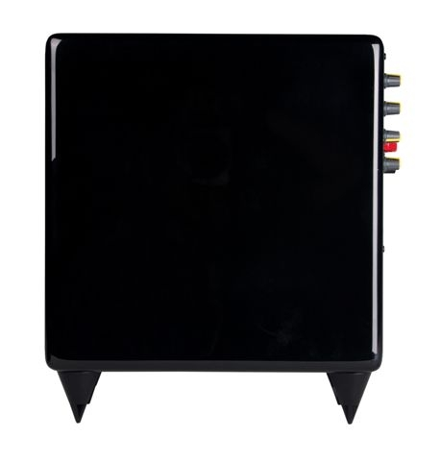
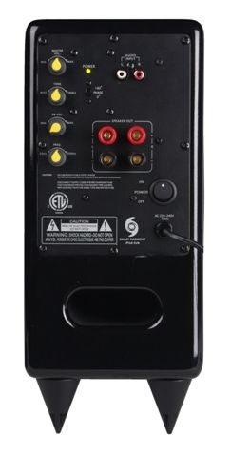 | 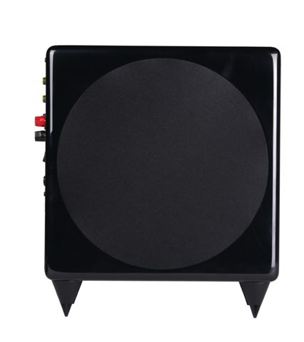

Dimension and Weight:
150W x 350H x 320D (mm)
7kg

Specifications:
- Cabinet thickness: 12mm with High Gloss (White and Black)

- Grill Cloth: Gray

- Woofer: 6 1/2 inches

- Frequency Response: 65-250Hz

- Impedance: 4Ω

- Power Handling 50W – 100W

Measuring Item | Condition | Unit | Nominal | Limit | Data
Input Sensitivity (50mv input) | L | v | 1.5 | ±0.2 | 1.5
 | R | v | 1.5 | ±0.2 | 1.5
 | Subwoofer | v | 4.5 | ±0.5 | 4.5
THD 10% Output Power (EIA) | L | v | 20 | ±5 | 20
 | R | v | 20 | ±5 | 20
 | Subwoofer | v | 20 | ±5 | 20
Power Handling | 50w (100w Max.)
lnput Impedance |  | ohm | 47k | ±10 | 10
Speaker Impedance |  | ohm | 10 | ±3 | 10
Impedance | 4 ohm
Distortion (1v input) | 1 watt | % | 0.1 | ±10 | 0.06%
Frequency Response | 65Hz - 250Hz
S/N Ration |  | dB | 70 | ±10 | 60
Hum and Noise (MIN Vol) | L | mv | 1.5 | ±0.5 | 1.2
 | R | mv | 1.5 | ±0.5 | 1.2
 | Subwoofer | mv | 2 | ±0.5 | 2
Hum and Noise (MAX Vol) | Subwoofer | mv | 4 | ±0.5 | 2.5

